
Object Services and Consulting, Inc.

Menu-based Natural Language Interfaces
what an end user sees when using MBNLI

Paul Pazandak, Craig Thompson
mailto:thompson@objs.com
972-612-6998

The Basic Idea
Natural language seems like a great idea for communicating with computers. Indeed, computers are able to process natural language in several areas: text to speech, speech to text, text translation, and keyword-based retrieval. But the area of natural language interfaces (NLI), where the computer processes complex queries or commands, has enjoyed very limited success, so much so that natural language is not much used in user interface development.
To understand why, try typing or speaking to a system that has a NLI – most of your questions and commands will not be understood because they overshoot the capabilities of the NLI system or the underlying application it interfaces to. In addition, you won’t really know about some things you could ask about (does the system handle map or statistical queries?) so your questions and commands will also undershoot the capabilities of the NLI system. This mismatch between user expectations and NLI system capabilities is called the habitability problem.
Menu-based Natural Language Interface (MBNLI) technology uses standard NLI technology but in a directed completion-based way to restrict the language and guide the user to just the capabilities of the NLI and underlying system. The technology targets a large unfilled niche in user interface design enabling unskilled users to make complex queries and commands. Interface development is much easier and has been automated in the case of MBNLI interfaces to relational DBMS systems.
OBJS MBNLI is developing a toolkit containing tools for creating and delivering NLI interfaces. The core technology is attribute grammars and a predictive parser. The prototype runs on Win 95/98/NT/2000.

Copyright 2001 Object Services and Consulting, Inc. All Rights Reserved.

Cascading Popup Menus
The user composes a sentence either by typing it in or selecting items from a cascade of menus driven by the grammar and predictive parser. Other supported MBNLI UIs provide speech and a space efficient sentence-completion menu configuration.
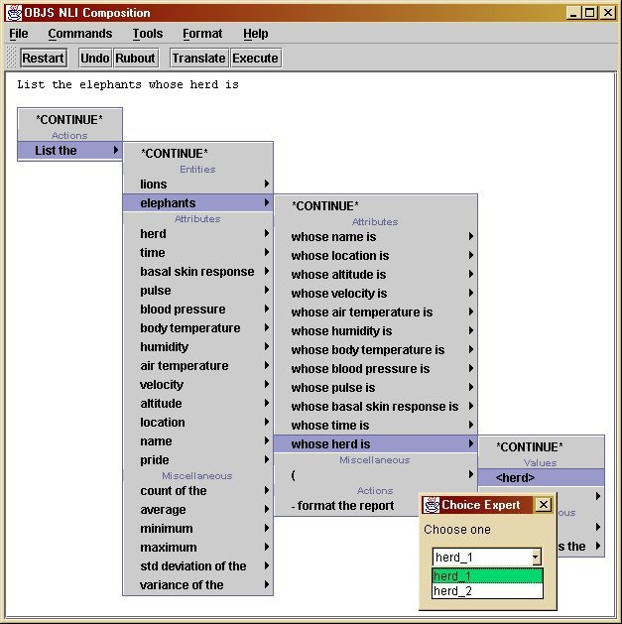
The buttons and their functionality are:
- Restart - erases the entire sentence and reinitializes the parser to begin again.
- Undo - erases the last phrase selected or character of the phrase being typed in.
- Rubout - erases the last phrase selected
- Translate - translate the sentence to SQL and display it in a separate window.
- Execute - translate the sentence to SQL, send the query to a database, and display the result in a separate window.

Domain Experts
Domain experts provide domain-specific support for specifying values. If an expert is selected, a menu supports the user in specifying a value. For instance, a DBMS choice expert is shown on the previous page and a type-in expert is shown below. MBNLI design supports an extensible library of experts (e.g., date, map).
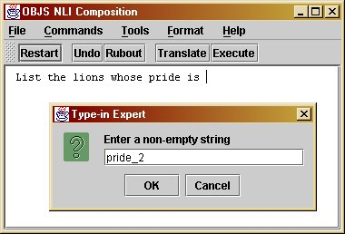

Query Translation
In the widely useful case of relational databases, default standard grammars and translations are provided and can be combined with DBMS schemas at run time to automate the generation of MBNLI interfaces to DBMS systems that use SQL. To view the SQL for a composed sentence, the user clicks on the Translate button. The sentence and SQL are displayed in a TextArea that can be edited:

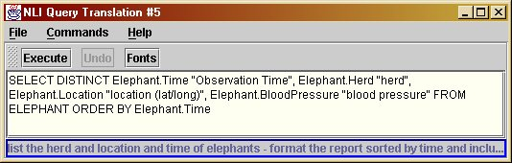

Query Execution
To execute the query and view the query result, one clicks on the Execute button in either the main NLI window or the translate window:

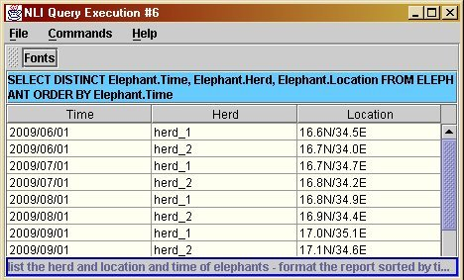

Generating New Interfaces
An interface generator called the Portable Specification Editor (PSE) is used to generate new interfaces to relational DBMS databases. It attaches to any ODBC database, extracts schema and other information, and that information parameterizes a grammar and lexicon so with the push of a button an interface is generated. The interface developer can be an end user or someone who builds interfaces for end users.
