Taming Cyber Incognito
Tools for Surveying Dynamic/Reconfigurable Software Landscapes

David L. Wells and Paul Pazandak
Object Services and Consulting, Inc.
{wells, pazandak}@objs.com

Abstract
Static models derived from specifications are inherently inadequate for capturing the reality of dynamic, reconfigurable software. Instead, continually updated models that combine static and dynamic information about software requirements, architectural patterns, components, connectivity, actions, and resource utilization are necessary. The Software Surveyor is an extensible toolkit for collecting, disseminating, and analyzing such dynamic information. The architecture and current status of Software Surveyor are presented, and the system’s use is illustrated through an example application in the information fusion domain.

Introduction
The power and flexibility of modern software makes the software landscape increasingly a cyber incognita, analogous to the terra incognita (unknown territory) that baffled explorers, frightened merchants and impeded progress hundreds of years ago. Cyber incognita’s equivalent of maps, surveying instruments, and marked trails are design specifications, monitoring and diagnostic tools, and descriptions of applications’ normative behavior; all are as inadequate in cyber incognita today as their equivalents were in terra incognita 200 years ago. Design specifications are incomplete, inaccurate, or inconsistent; software probes cannot observe all significant events; techniques to correlate independently recorded observations are limited; and descriptions of normative behavior are often (especially in Web-based, agent, or survivable systems) described as “best effort” with no concrete notion of what that means. Further, the dynamic nature of many modern applications means that they are continually reorganizing themselves in response to changed user demands or resource availability; imagine Lewis and Clark having to deal with rivers and mountains that changed position every few hours. Hic sunt dracones – here are dragons.
A multi-faceted approach to remedying this situation is needed, including: 1) formal, static specifications of required/expected behavior, and 2) dynamic, runtime tools to flesh out the static specifications and to verify that the application is adhering to specifications. Software Surveyor [], a framework and an extensible set of probes and gauges to dynamically deduce the connectivity and behavior of evolving, under-specified software applications being developed as part of the DARPA DASADA Program [], provides many of the required dynamic capabilities and is compatible with the coming generation of modeling tools.
Section 2 of this paper discusses the form and uses of application models. Section 3 argues that static techniques are inherently insufficient for modeling modern software, while Section 4 discusses how static and dynamic analysis together can provide better models and discusses the kinds of information that can be obtained from various points in the software lifecycle. Section 5 presents Software Surveyor; a suite of architecturally related tools to collect, disseminate, and analyze information collected by runtime application monitoring. Section 6 presents an extended example of the use of Software Surveyor as applied to a loosely coupled Internet information analysis application. Section 7 identifies future work.

The Form & Use of Models
A model is an abstraction of a real system that captures the essential elements, organization, and activities of that system. Models can define “families of systems” or can define a specific instantiation of a system. The xArch system [] based on the Acme architecture definition language (ADL) [] makes this distinction explicit and uses the same modeling language to define models at each level.
Models can be used to constrain system organization or behavior and provide a basis for reasoning about, simulating, or validating behavior. For example:
How are the components connected? Do all connections meet specifications? Are all required bindings satisfied? Are unexpected components present? Do seemingly valid bindings produce expected behavior?
How, when, and why were the connections made? Who/what is responsible for an incorrect binding? Can a specific binding be changed? Is some binding tool (e.g., a Trader) using a bad selection policy? Are binding decisions made consistently?
What is the physical organization? Where are the components physically located? Where are choke points? Are untrusted machines being used? Are components vulnerable to physical assault/failure?
How does the current configuration compare to other configurations? Is the configuration consistent with the specification? How does a faulty configuration differ from a known good configuration? What differences exist between a currently faulty configuration and a previously working configuration?
Has a configuration changed? What changed? What process changed it? Was a change authorized? Did an authorized change actually happen? Does a change indicate a possible intrusion or failure?
Are there unused or unexpected components? This provides an opportunity for pruning the configuration to reduce footprint, to identify potential viruses and Trojan Horses, and to simplify the evolution process by not evolving unused modules.
What are the activity patterns? Are QoS constraints met and are there hot spots? Are there patterns of connection quiescence? This provides input to resource allocation & optimization tools and helps to identify “suspicious” activity. It can also be used to allow unused connections to drop safely and identify “windows of opportunity” for evolution.
How are the components interacting? What functions are invoked on the various connections? This is useful for ensuring compliance with specifications, security monitoring, and general diagnostics.
Are there unused functions/methods of libraries/
components? This can allow more specific library loading to reduce code footprint and simplify evolution by only upgrading functionality actually in use.
A model is inherently an approximation of the system being modeled. The approximation occurs because the model suppresses (unnecessary) details or because the model is incorrect in some respect(s). This requires an understanding of:
- What constitutes an “essential element, organization, and activity of the system”.
- How those items can be determined.
In this work, we consider componentware; software that is assembled by composing immutable, preexisting parts, possibly using “glue” software to facilitate the composition. The model of a componentware system is an annotated graph, whose nodes correspond to the immutable components and whose edges correspond to bindings (connections, whether actively used or not) between components. This logical organization constitutes the topology of the model. There is also a geometry corresponding to the physical computing, storage, and communications resources on which the components execute. Both may change over time, and the geometry may change while the topology remains constant (e.g., a process is relocated) [].
Thus, the following are the salient constructs of a configuration:
- The immutable components
- The logical connections between components (who calls whom & protocols used)
- The resources on which the components execute (hardware & software environments)
- The connection medium (physical paths)
Applications can be profiled at many levels of abstraction. Since the point of modeling is to support some set(s) of users, it is appropriate to choose level(s) of abstraction that are meaningful to them. This means that the granularity of the model should be such that the modeled components are familiar to the users and that use of the model can point to practical remedial actions (e.g., restart a service, use alternate communications, choose a service alternative, do without a non-responsive service) that can be taken given the skills and tools available to the users.
Matching the level of abstraction to the actions that can be taken is particularly important, since if the proper tools are lacking to make a change, a portion of the application is immutable to that class of users and therefore should be considered as a component from that point of view regardless of how complex it might actually be. For instance, modifying the implementation or installation of a remote service might not be allowed, but switching to an alternate service might be. In this case, the knowledge that the remote service has failed is sufficient; details about how and why it failed are of no use and only create mental clutter. In Section 6 we will see how these concepts are applied in practice.
Note however, that a model is actually a hypergraph. An immutable component in one abstraction may in fact expand into a graph of smaller components in a finer-grained view or a view from a different perspective. This is good, because it again allows viewing a configuration at a useful level of detail for the task at hand. An implication of this is that Software Surveyor must coordinate its collection, analysis, and presentation activities based on the desired view(s). This notion is called focus, and is discussed further in Section 7.

Why Static Modeling is Insufficient
It has always been impossible to completely characterize everything important about large, distributed applications, but with yesterday’s relatively static applications it was possible to specify much of the relevant information as part of the design, implementation, or deployment processes and then to test in a constrained operating environment to ensure that the desired behavior was (more or less) achieved prior to actual use. Often, this was not particularly well done (especially when relying on multi-source components from vendors with varying quality controls and documentation standards), but at least there was a hope that with better tools, methodology, or training, it could be accomplished.
However, this is a vain hope with modern, loosely coupled software that is often constructed from a mix of custom and preexisting components originating from a variety of sources. Individual components can (and frequently do) evolve independently due to new requirements, bug fixes, performance improvements, and feature enhancements. Field upgrades of deployed code (e.g., by providing new libraries) can unwittingly cause problems for other programs that had previously been performing correctly (e.g., a DLL is upgraded to support application A, but causes problems for application B which also uses it). Lack of complete dependency information makes it impossible to know what might be affected by the upgrade or even to know that a subsequent malfunction might be related to a particular change. New components may be introduced, including components that are generated on-the-fly from specifications of client requirements and service provider capabilities and are never seen by a human or subjected to normal testing. Even the types of the objects/data passed between components are malleable; programming language types are typically encoded in XML and later reconstituted for program use by translator tools that operate based on metadata stored in files associated with the data.
Flexible architectures with loose inter-module coupling has many well known advantages, but in consequence, the developer of a component or application may not know the identity of all components, the types or exact behavior of those components, their location, or even the types of the information actually being exchanged. This makes it very difficult to predict the effect of proposed changes, to determine why something does not work properly, or even to figure out why something works well in one environment but does not work in a seemingly comparable environment.
Further, much of the new software is designed to make many of its configuration decisions on the fly, depending on its environment. Frequently, these decisions are outside the direct control of the application developer. This includes mobile code that binds to local instances of services, CORBA services that are bound to existing servers by a Trader, and survivable systems that reconfigure to use remaining resources after attack or failure. Not only is it currently difficult or impossible to determine how connectivity has been decided, it is often the case that critical decisions are made without propagating the knowledge that a decision even has been made back to the proper authorities.
Finally, the operating environment is frequently too complex to replicate for testing purposes (imagine replicating the Internet to test software that filters and streams time-critical data over an open network).
The key observation is that it is becoming increasingly difficult to know in advance how components actually use each other due to greater system complexity combined with more dynamic configuration choices. Design specifications, architecture descriptions and formal methods, configuration information produced during the process of instantiating and deploying code, and tools that profile systems under development all provide valuable information, but even collectively they still leave notable gaps in the community’s ability to gather “ground truth” about the real-world behavior of distributed, component-based systems. A brief examination of these sources of information shows why this is so.
Formal specifications are good for describing desired behavior in a way that supports reasoning about system properties; however, implementation details are difficult to capture this way and formal specifications for externally developed components are hard to come by. Since few systems work in isolation from all external components (including operating systems and communications software), formal specifications are necessarily incomplete.
Software construction tools (compilers, linkers, configuration management, etc.) that instantiate and manage software generate a large amount of information that is generally complete and accurate when produced. However, this kind of information suffers from one serious shortcoming: it may accurately reflect the connections that existed when the software was first created, but there is no feedback process to ensure that it remains accurate as the system evolves, particularly if the changes were caused by a tool other than the one that produced the initial information. Further, such tools generally only identify the static interconnectedness graph of an application and not how those interconnections can be used.
Profiling tools found in software development environments do capture some of the dynamic behavior of systems. However, they have serious coverage gaps when considered in the context of component-based systems where key components are frequently outside the domain of the monitoring tools (wrong language, different platform, remote) and hence cannot be profiled. Even with integrated development environments that support multiple environments and distributed debugging, the problem remains that the tools are intended for use during the development phase rather than during the entire lifecycle of the system and as a result are too complex and resource intensive for everyday use with deployed systems.
Real, running component-based systems thus have behavior that cannot be adequately described without directly observing the behavior of the system “in the wild”. A major thrust of the Software Surveyor project is to construct living, constantly updated models of dynamic, under-specified applications by combining static information about the modeled system with information about binding decisions, component execution and interactions, and resource use collected during runtime. Software Surveyor fills a void left by more traditional tools that are employed prior to program use.

Perpetual Modeling
Information about application structure and behavior can be obtained from several sources, including design artifacts, application artifacts, runtime monitoring, and historical information about prior executions. However, no single source can provide all the information necessary to completely profile an application, so it is necessary to extract or collect information from all of these sources. Collectively, they:
- Identify the kinds of components and interactions that are important enough to profile,
- Provide a conceptual framework in which collected information can be organized,
- Tell where to look to collect the necessary information to allow a profile to be constructed,
- Provide expectations to which observed organization and behavior can be compared.

Information Sources
Design Artifacts: Design artifacts are descriptions of intended configurations and behavior. Static specifications limit undesirable behavior and mandate certain desirable behaviors. Static design specifications cannot deal adequately with the following kinds of dynamic behavior without unduly restricting the benefits of the dynamism: dynamic binding decisions by third-party binders, dynamic addition, deletion, or movement of independent data sources, changes to the schema of independent data sources and components, transient behavior. Static specifications cannot be arbitrarily fine grained and cannot generally anticipate all environments and conditions in which the software may be expected to operate. Further, enforcement of many types of design constraints, e.g., quality of service, requires runtime monitoring.
Application Artifacts: There are two kinds of application artifacts: information (such as configuration and source code files) that are below the level of design and are used to further reify the application’s configuration, and information that the application produces that is generally available without using probes. Both may require interpretation to be useful, but are easily captured. In addition to providing concrete information, they also indicate which events to look for; i.e., where to place probes. Generally, application artifacts do not provide sufficient insight into how the information was produced (the job of design artifacts and runtime monitoring) or what its purpose is (the job of design artifacts). Also, failures are particularly hard to analyze using only application artifacts. Finally, because separate executions are often totally independent, it is hard to detect anomalies from one execution to another.
Runtime Monitoring: Runtime monitoring of an application and its environment can add details that are left unspecified by design specifications and can identify the specific elements filling “roles” defined by the design. The specific elements might not have existed when the design specification was made and/or might be selected by third party software outside the control of the application. Finally, runtime monitoring is necessary to ensure that design constraints are being met. Runtime monitoring cannot tell why a particular event occurred, merely that it has. Interpretation must be with respect to design and application artifacts.
Historical Record: The historical record is the time-series behavior observed through runtime monitoring of multiple executions of the application. This can be used to informally determine expectations of behavior in any of the dimensions that can be monitored, and can serve as a basis for detecting anomalous behavior. In a sense, the historical record forms a piece of the design specification: “it should work in a certain way because that’s the way it always has worked”.

Information Profiling
Profiling requires a diverse set of probes to collect information from the sources described above. Thus, a variety of probe types are needed to profile even reasonably complex applications. Reasons for using different kinds of probes include:
- Probes are designed to work in specific environments. The types of probes that will be required for a given deployment will depend upon the data gathering requirements, the application's implementation language, source code access, and operating environment.
- Probes have different information capture capability. Even if environmentally compatible, and monitoring the same event, different probes may be able to capture different information about the event. For example, when a process spawns a child process, a new Windows task is created. An application-specific or language-specific probe could capture the arguments used to start the new task, but information like process-id and memory utilization that could be used to externally monitor the task are better captured using either environmental probes or probes that monitor O/S events like process creation.
- Security and ownership concerns may mandate that only certain kinds of probes are allowed to be placed and that only certain insertion points are possible. This indicates another reason that choices in probe technology have value.
The following artifacts are of interest:
Component Types: The types of components that are significant to the intended users of the gauge outputs. The definition of the components of interest is dictated by the level of abstraction at which a particular class of users understands and manipulates the application. See [Error: Reference source not found] for a further discussion of how components of interest are determined. Once the interesting classes of components are identified, the classes of connections that must be profiled become obvious.
Architectural Patterns: Patterns (in the Gamma [] sense) defining how components of interest can be connected together. Examples are trees, object buses, server farms, object factories, etc. An application may employ many patterns. The key point is that patterns define the way in which components will interact in the application, not which specific components fill the various roles in the patterns. Architectural patterns provide a framework within which components and connections may be interpreted.
Static Connectivity: Mandated connectivity between specific components of interest. This is more precise than an architectural pattern, since it specifies more detail and identifies particular components filling the various roles.
Interaction Protocols: The protocols by which components of interest are allowed to interact. Examples are HTTP, CORBA, Java RMI, SOAP, email, etc. Since component interactions are a prime place to insert probes, protocol documentation can tell where and how those probes can be inserted.
Initial Configuration: When applications are deployed, they have some initial configuration defined by mechanisms such as configuration files, registries, or the like. Some defaulting may be used to complete a partial specification (e.g., localhost is mapped to an IP address).
Information Output: Most applications produce some output in an easily accessible form such as displays, file or database writes, or the use of StdOut and StdError. Such output can represent the primary results of the application or can be diagnostic. In general it is easily captured without inserting probes directly into the application since it is intended to be exposed; however, it frequently requires parsing to interpret its meaning.
Dynamic Components: It is necessary to know the components actually in use and desirable to know the set of components available for use. Both can change over time. The available components may be explicitly expressed in some kind of registry, may be a set identified on-the-fly by a binding mechanism such as a Trader, or be generated on-the-fly from specifications (e.g., glueware) or from data accessed by the application. In addition to knowing which components are available and in use, it is desirable to know why (i.e., by what mechanism) they were selected.
Dynamic Bindings: Component connectivity must be tracked over time. This includes the components connected, the roles they play in a connection, and how/why the connection was established (e.g., the binding agent and the binding arguments). Dynamic bindings must be checked for adherence to the architectural patterns defined for the application.
Messaging Activity: This refers to all kinds of messaging between the components of interest. The types of these communications are defined by the interaction protocols identified elsewhere. It includes the initial message, response, and any exceptions thrown. Note that exceptions need not be returned to the original caller, as the recipient will be defined by the interaction protocol.
Environment: Required (specified) and actual (sensed) environmental properties such as operating system, CPU speed, memory, disk, bandwidth, other required software should be captured and compared to determine if the requirements are met.
Extra-application resource utilization. How much of various resources are being used by other applications and are therefore unavailable to the application of interest? This is obviously a dynamic issue, in that the other co-resident applications will change from execution to execution. This is of interest since it may predict ability of the application to meet QoS requirements, user expectations (or may make it possible to warn the user that the results will be forthcoming, but it may take longer), or even the ability of the application to succeed. Under certain load conditions, it may be determined that it would be best to defer the execution since it is highly likely that it won’t be able to complete.
Data Accesses: Data access refers to the data sources accessed (e.g., a particular database), the arguments used in the access (e.g., a query), and the items returned (e.g., the specific tuples). Types of data accesses of frequent interest are files, databases, and Web pages. Application behavior can be strongly influenced by file content. For example, the schema for an XML page is generally defined in another page containing a DTD or XML Schema definition. This may in turn be used by parsers to generate programming language (e.g., Java) objects, so in effect the data accesses may cause the generation of new components.
Expectations of Behavior: It is important to know if an application is behaving properly. This takes many forms, including constraints on (full or partial) results, quality of service measurements, resource consumption, or just a “feel” that the system is behaving properly based on experience with previous uses. Such information can be captured from specifications, the historical record of prior executions, and user feedback. For example, the amount of time required to produce a complex result might not be formally specifiable, but in practice may fall into a relatively small range. Similarly, a user may know that a certain data gathering activity usually produces a certain number of “hits” without being able to state precisely why this is so.
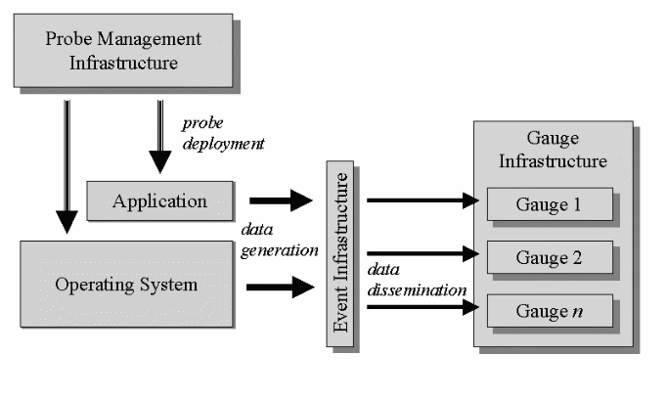
Figure 1. Software Surveyor Architecture

Software Surveyor
OBJS’ Software Surveyor is a profiling toolkit to dynamically deduce and render the runtime configuration and behavior of evolving, component-based software. Information is synthesized from multiple sources and combined and rendered in a variety of formats and made easily accessible via the Web.
Software Surveyor addresses three distinct issues:
- What is the application doing?
- What is it supposed to be doing?
- Is it doing what it is supposed to?
Software Surveyor requires limited prior knowledge of application connectivity and has the ability to dynamically deploy probes, allowing its use with dynamically reorganizing applications and those lacking complete specifications. The next two subsections discuss the design of Software Surveyor and its current implementation status.

Architecture
The toolkit uses a three-tiered architecture (Figure 1) for runtime application analysis. The tiers correspond to data generation, data dissemination, and data consumption/analysis. The probe management infrastructure (data generation layer) manages and deploys probes to collect a variety of information from the running application and its environment. The probes pass on the collected information in the form of events to the distributed event infrastructure (data dissemination layer). This layer is responsible for relaying the events to interested subscribers, called gauges, which are part of the gauge infrastructure (data consumption layer). The gauges merge the event/information streams and make sense of it. In addi-
tion, results of this analysis are aggregated to identify “behavioral norms” to augment incomplete performance specifications. Finally, the probe infrastructure and behavioral norms can be used to signal users when the system is operating anomalously.
Probe deployment involves the insertion of probes, statically or dynamically, into data streams and execution flows so they can monitor and report on activity. The probe insertion technique will vary depending upon what is being instrumented, and when it can be or must be instrumented. For example, some probe types (source code probes) require precompilation-time insertion, while other probe types can be inserted into binary or bytecode at pre-runtime, or possibly during runtime.
Probe management is required for activation, deactivation, static and dynamic configuration, and probe removal.
Once deployed the probes generate typed information streams. We have adopted a basic event classification scheme that includes descriptors for type, subtype, and probed component name. This information is used by the event infrastructure and gauges for filtering and processing. Data emission rates may depend upon the type of probe, how it is configured, and the amount of activity at the insertion point. For example, one environmental probe (e.g. monitoring system activity) may be configured to emit resource utilization every 5 seconds, while an application probe (e.g. installed into the execution flow) may emit data whenever the method it instruments is invoked.
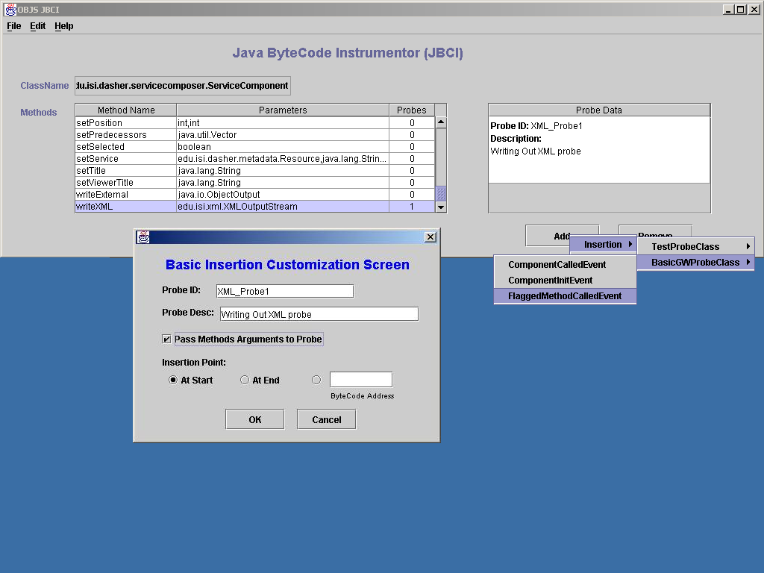
The data emitted by each probe is sent as events to the distributed event infrastructure so that it may be disseminated to interested gauges for analysis and visualization. The event infrastructure will accept data from any probe source, allowing Software Surveyor to support compatible third party probes.
Gauges subscribe to events by specifying event types or specific qualifying values or conditions based upon attribute values contained within the events. They may subscribe to multiple event types. Once a gauge receives events it may combine data from multiple event streams, perform analyses, synthesize new events, render visualizations, send feedback to the probes, and pass on information to other gauges.

Current Implementation Status
The current version of Software Surveyor includes a rudimentary probe management infrastructure including a probe insertion tool and several types of probes; a distributed event server; and several gauges.
In the initial version of Software Surveyor, we have created two types of probes:
- AppliProbes are used to instrument the application, and
- EnviroProbes are used to collect data from the operating environment.
Our current set of AppliProbes is implemented in Java. They are used to instrument both the target application and the underlying Java core class library. The probes generally emit method invocation arguments and related environmental data such as stack traces, invocation time, and thread information. Customized probes may emit other variables as well.
A subset of these are precompilation-time probes requiring insertion into source code. They are generally specific to the target application and are used to extract information that could otherwise not be acquired. We have also directly instrumented several core Java library classes to monitor application-environment communication, such as File, URL, and I/O stream access. These instrumented classes can be reused for any Java-based application monitoring.
Another subset of AppliProbes used are bytecode probes, which are inserted directly into Java bytecode at pre-runtime, and to a limited extent during runtime. Bytecode probes are inserted using a tool called the Java ByteCode Instrumentor (JBCI).
The Java ByteCode Instrumentor (Figure 2) automates the insertion of probes and probe stubs into Java bytecode. JBCI modifies .class files by inserting bytecode using customizable instrumentation techniques. JBCI can be extended with new probes and instrumentation techniques. Probes implemented in other languages can be called via JNI.
Figure 2. Java ByteCode Instrumentor
Our current EnviroProbes call upon operating system utilities to gather information on system status and resource usage. They monitor system-wide CPU utilization, application CPU utilization, and TCP bandwidth. They generate events at discrete configurable intervals.
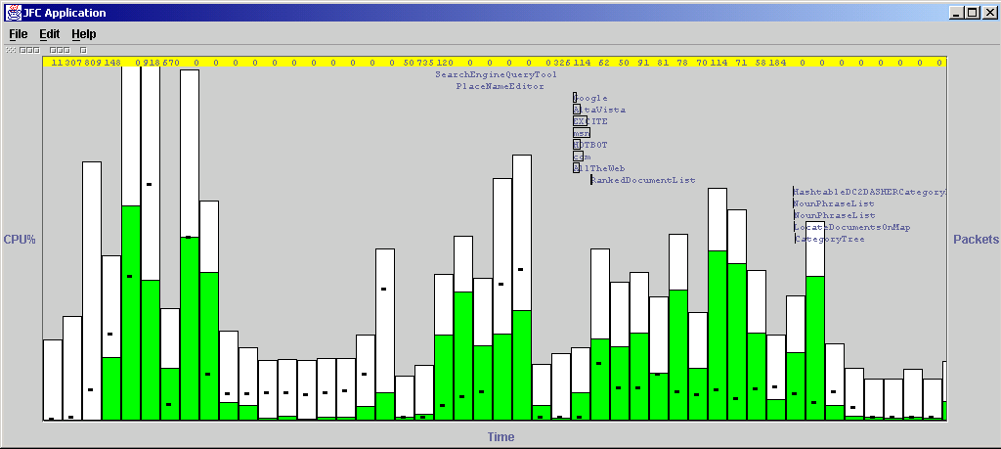
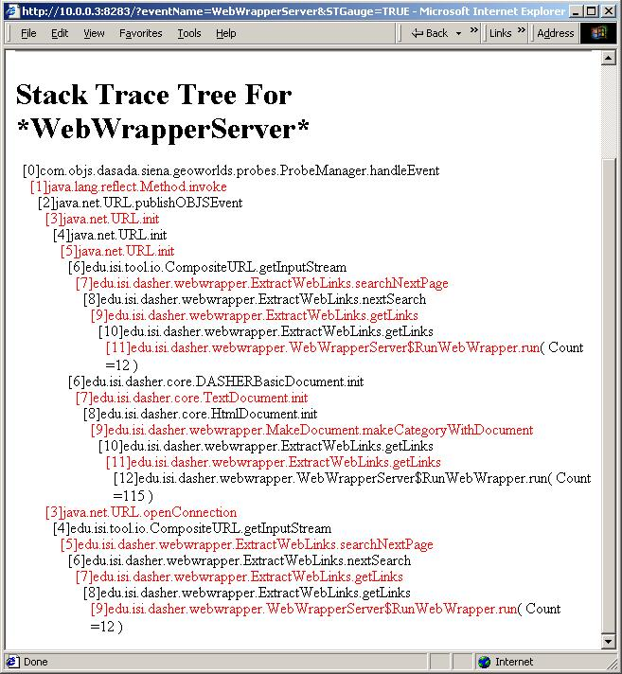
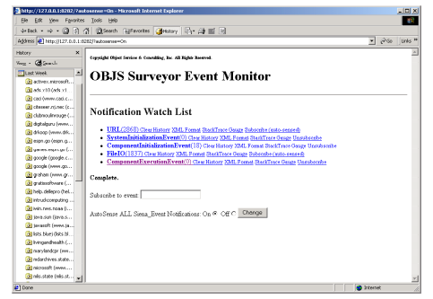
While the current version of the probe infrastructure relies heavily on manually inserted probes, the next version will support on-the-fly probe insertion into running Java programs.
Figure 3. Software Surveyor Gauges
The probe-generated events are distributed by the Siena Event Distribution Infrastructure []. Siena uses a hierarchical distributed server architecture enabling the instrumentation and monitoring of distributed applications. Software Surveyor gauges subscribe to and receive events from Siena.
The current set of gauges include Coalescer, EventMonitor, EventMerger, StackTracer, Historian, and Mapper. Once they receive events from the event server, which contain XML-formatted data, the XML is deserialized to first class Java objects for direct manipulation (Figure 3).
Coalescer merges streams of separately collected event information and renders this information on a timeline chart, performing limited aggregation of events by time interval.
EventMonitor categorizes events by type and renders HTML- and XML-based displayable summaries with expandable detail. EventMonitor includes a web server to support browser-based access. It can be configured to subscribe to any subset of, or all, published events.
EventMerger, an extension of EventMonitor, performs event unification prior to rendering. Event streams may report on the same activities, but at differing levels from within the application. EventMerger identifies related streams of events by analyzing event content (e.g. stack traces, event type/subtype, component names and other attribute values). This can help, for example, to view the overall activities of each probed component in the application.
StackTracer converts streams of application events into a trace of program execution and emits an XML representation. The events emitted by a probe may be generated via several different execution paths involving the probed method. This gauge provides insight into frequency of invocation along each path. It can also be used to filter out paths (and therefore events) so that particular application behavior can be isolated for further analysis.
Historian archives execution traces and computes statistics of behavior.
Mapper provides a visualization of the time-based relationships between events of an application.
Software Surveyor v1.0 is implemented in Java 1.3 and has been tested under Windows 2000. v1.0 requires Siena for event distribution. EnviroProbes is currently available only on Win2000 and WinNT.

An Example
We now illustrate the use of Software Surveyor in the construction and maintenance of a continuing application model. The selected application, GeoWorlds [], is an Internet information tool that allows intelligence analysts to define “scripts” to locate, filter, and organize collections of Web-based information. GeoWorlds is representative of a large class of loosely coupled, highly distributed applications in which exact configuration and behavior cannot be specified a priori. Third-party components are heavily used, configuration and data access decisions are made at runtime by tools outside the direct control of the application, and data sources may move, appear, become unavailable, and change their schemas without notice. As such, runtime monitoring and evaluation of behavior is necessary to provide analysts with high level, comprehensible support for determining whether a script is likely to work, whether a script is executing properly and making reasonable progress, and whether an information collection is plausible [].
Portions of GeoWorlds can be modeled statically. Eventually, the model (both the static and dynamic parts) will be represented in the Acme ADL [Error: Reference source not found]. Representing all aspects of the model in this common, mature modeling language will allow the use of existing visualization tools and will enable the use of architecture analysis tools to ensure that the dynamic behavior meets static constraints. In the following, significant components and activities appear in italics.
GeoWorlds software consists of a core that resides in a JVM and an extensible collection of external services that may be in a variety of languages and resident anywhere, including within the JVM containing the core. The services manipulate a collection of data sources (mostly Web pages) using scripts to produce InfoSpaces.
The GeoWorlds core consists of a ServiceComposer for graphically writing scripts and several job pools for scheduling services accessible via different technologies; e.g., RMI, CORBA).
The external services conform to a static architectural pattern (a DAG of services); the leaves are Web search engines that locate Web content, the internal nodes are data manipulation services that filter, extract content and organize collections of Web pages, and the roots are visualization services that provide different views of the InfoSpace. Information flow between nodes is encoded as XML pages describing the InfoSpace and documents as processed up to that point. Each service has input and output schema to which they must adhere in order to function properly. Scripts are checked for sanity when they are constructed to ensure that input and output schema requirements are met, but because services can change their schema without notice, this is not always accurate.
Data items of interest are the Web pages manipulated by GeoWorlds (both source and pages constructed to represent the structure of an information space), and ancillary data sources (databases and files) accessed by services as part of their own operation (e.g., a database mapping place names to lat/long coordinates); these are not known to GW and are a key source of bottlenecks and errors if bound incorrectly or unavailable.
The static model of GeoWorlds as described above provides the “shape” of the application and identifies the kinds of components and activities that must be modeled and monitored dynamically. However, it is clearly incomplete, since the services connected together into a script are written by analysts in the field and the pages accessed, how they flow through the script DAG as they are filtered and organized, and the behavior of an execution cannot be known until runtime.
Probes were embedded into the application to collect information about events identified by static analysis as being relevant; these included service start/stop, URL accesses, file accesses, and various initialization events. Whenever a probe detected such an event or condition, it was published as a Siena event that could be subscribed to by (remote) gauges. The Web-enabled Software Surveyor EventMonitor and EventMerger gauges (Figure 4) subscribed to these events and created summaries and stack traces of application activity that lead to these types of events.
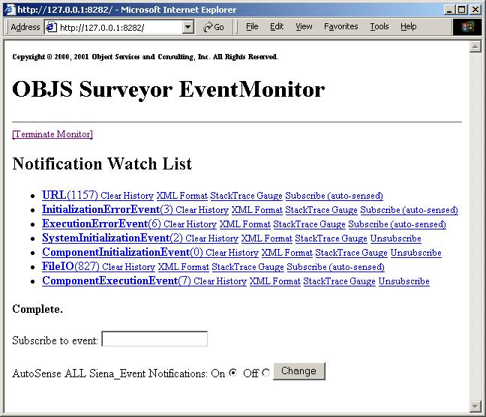
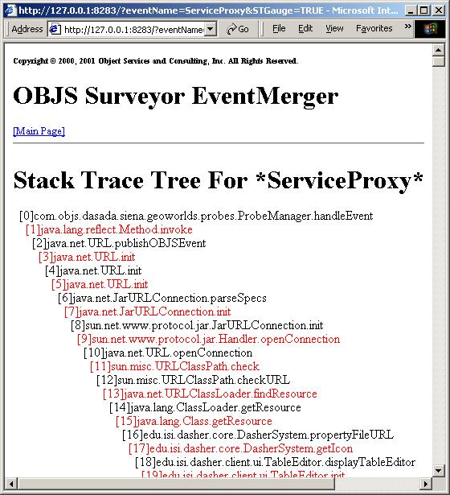
Figure 4. Event Monitor & Event Merger Gauges
Probes were also attached to the environment to periodically sample resource utilization of the GeoWorlds application and competing background activity. This information was subscribed by the Software Surveyor Coalescer, which also subscribed to a subset of the application events. These event streams were woven together to associate resource utilization, URL access, and GeoWorlds service activity, creating a timeline of script progress (Figure 5).

Figure 5. Coalescer Gauge with Mapper Interface
Finally, information produced by the Coalescer over several successful and unsuccessful script executions was used to make a first-order approximations to the application’s normative behavior under particular environmental and scripting assumptions.
Figure 6 shows the cumulative CPU activity of a particular script over time for successful and unsuccessful executions of a particular script. Executions under similar conditions, while not identical, tend to be similar, with failure having a very distinctive pattern. The objective of this is to determine statistically what the application can be expected to have accomplished in the way of service execution and URL accesses after certain amounts of time and resource consumption. These would in turn be used to parameterize future gauges that would warn when insufficient progress was being made based on previous experience.
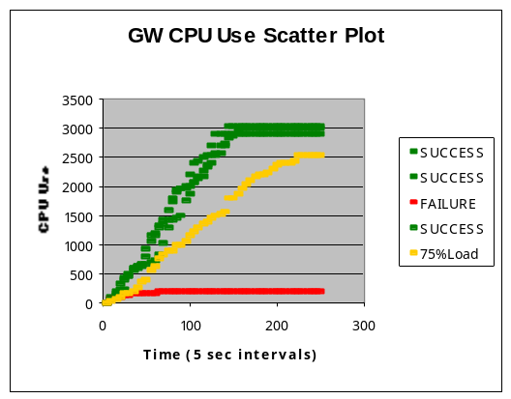
Figure 6. Historian Gauge
Monitoring technology will be widely used only if its use is easy. For Software Surveyor, this equates to the processes of placing and activating probes, setting up the event distribution infrastructure, getting gauges to subscribe to the events emitted by the probes on the application, and providing convenient viewers for the gauge output.
Mechanically, probe placement is easy. JBCI probes can be placed into Java bytecode using a GUI that presents information about the application's classes and allows the insertion of standardized probe code into the bytecode. At present, there is a small, but extensible, library of such standard bytecode probes (since not many people want to actually write bytecode). Some of the Java core classes (particularly those associated with communications) have had probes inserted; to use these probes, all that is necessary is to link in the modified classes. Users with special needs (and access to application source) are welcome to write their own probes taking advantage of existing event distribution facilities. Environmental probe use simply requires knowing the process(es) to be monitored. A more complex issue is determining where to place probes. In the example described above, this required going through the application's documentation and source directories to determine how to draw component boundaries and to identify the communications mechanisms used by the application. In next year's version of Software Surveyor we plan to experiment with the use of architectural models to aid in the process of identifying where to place probes. (see Open Issues and Next Steps).
Setting up the event infrastructure is easy. One or more Siena event servers are started to disseminate events signaled by the probes. In addition, each Software Surveyor gauge uses a Web server to make gauge results available.
As with probe placement, getting the gauges to subscribe to the proper set of events has an easy mechanical component and a more difficult modeling component that will be dealt with next year. Subscribing to events requires simple calls to the Siena infrastructure, identifying the events of interest to the particular gauge. Determining which events to subscribe requires knowledge of the kinds of events that might be signaled by the probes monitoring the application(s) of interest. Again, see Open Issues and Next Steps for a sketch of the anticipated model-based solution.
Finally, gauge output is readily viewable anywhere via HTTP using standard browsers.

Open Issues & Next steps
Probe Infrastructure Improvements. Over the next year, we plan to improve the performance, coverage and flexibility of the probe infrastructure.
The Java-based AppliProbes are about as efficient as they can be, but the current EnviroProbes are inefficient because their use of the facilities of the Windows Alerter mandates a needless process switch in order to emit Siena events; this will be rectified. Depending on the level of abstraction, an application may emit thousands of events per second. This places an excessive load on the event distribution layer, particularly if events are being subscribed over a WAN. We are working with the Siena developers and the DASADA Event Infrastructure WG to develop a caching scheme that will allow events to be batched and transmitted in a group. This is more complicated than it sounds, since simple batching until a given number of events are collected may result in unacceptable delay in delivering events. Thus, transmission must be timed as well as batched. Further, because different subscribers may consume events at different rates, batching may be forced to use the lowest batching factor and therefore become useless. We will also add the ability to focus the attention of probes on areas of interest within the application. The notion of “focus” is discussed further below, but from a performance standpoint, the intent is to improve performance by reducing the number of events collected. This is essential, since no matter how fast the event distribution infrastructure is made, it will be possible to generate enough events to overwhelm it.
Coverage will be improved by better support for third-party probes and gauges and convergence toward a common event schema. Probes implemented in other languages can be called via JNI from Java probe stubs, and probes to monitor applications in other languages are supported by Siena’s Java and C++ interfaces. Events are currently encoded in XML by many DASADA projects, but every project uses its own schema. A decision was made at the start of the project to defer the definition of a standard schema until more experience was obtained; a first cut at a common schema will be made in the next year.
Adding programmatic interfaces to the probe infrastructure will increase flexibility. This will allow activating/deactivating probes and dynamic probe placement to expand coverage of an application as it evolves. The next version of JBCI will support on-the-fly probe insertion into running programs (without any source code access) to support dynamic focus - evolving JBCI into a more fully capable Probe management tool.
Focus. Focus is the ability to concentrate attention on a particular aspect of the system being modeled. Focus has several aspects.
First is presentation; limiting the amount of information that is presented to a user so that the information presented can be used more easily, in essence trying to eliminate information overload. However, if the consumer of monitored information is a gauge, this becomes a non-issue.
A second aspect of controlling focus is the ability to limit the kinds and amount of information collected in order to avoid placing excess load on the event distribution infrastructure and affecting application performance by signaling too many events. It is advantageous to place/activate probes only where needed to fill important gaps in the evolving model. For example, there is no use collecting information that cannot be used (either by gauges or to take corrective action) or that could equally well be determined statically (e.g., why dynamically determine that a connection uses TCP/IP if that was statically bound and not subject to dynamic change).
A third issue of focus is to address the issue of incomplete probe coverage. The collection of available probes determines how accurately an application can be modeled. Depending on the available types of probes and their placement, it may not be possible to profile all parts of a model adequately. Such areas are essentially “out of focus”, and given the lack of information, they must also be treated as immutable components. Security constraints may further prevent certain monitoring, even if the probes to do so exist. Thus, lack of focus may be involuntary.
In the next year, we will be developing a theory of focus and mechanisms to change focus. In particular, we need to be able to describe what is and is not known; lack of information about an event could mean that the event did not occur or that it was not in focus at the time it did occur and hence was not seen. We also need a way to represent focus in the event schema and in gauge outputs. Finally, we need to extend the probe management infrastructure to allow probes to report their focus (if possible) and to change the focus by inserting/removing probes, activating/deactivating them, and ordering them to collect different kinds of information. This in turn will require a better means of describing probe capabilities architecturally.
Model unification. Finally, we want to integrate dynamically collected information with static information and represent the combination in a single evolving model of an application’s deployment and behavior. We anticipate using xArch [Error: Reference source not found] for this purpose. In xArch, a distinction is made between the model of a family of systems and a specific instantiation of a member of that family. Not only would this provide a convenient modeling and display framework, but would enable a number of existing architectural analysis tools to be applied to dynamically gathered and modeled information.
Both probe placement and event subscription assume knowledge of the general structure of the application and the kinds of events that a probe is capable of monitoring. Both appear to be amenable to simplification through the use of architectural models of the application (should such models exist). As noted above, two levels of architectural

models can provide information about the structure and behavior of a family of systems and of a specific instantiation. It appears that there is sufficient information in these models to significantly ease the process of determining where to place probes. In the next year, we plan to build a prototype tool to use ADL models to drive probe placement. Because this tool will then know where probes have been placed to carry out a particular monitoring activity, it can also inform the recipient gauges information about events to which they should subscribe.

Bibliography

[?] Software Surveyor Project Homepage, OBJS, 2001. www.objs.com/SoftwareSurveyor
[?] DARPA DASADA Program Homepage, Defense Advanced Research Projects Agency, 2001. dtsn.darpa.mil/iso/programtemp.asp?mode=340
[?] xArch Project Homepage, UC-Irvine, 2001. www.isr.uci.edu/projects/xarch
[?] D. Garlan, R.T. Monroe, D. Wile, "ACME: An Architecture Description Interchange Language," Proceedings of CASCON'97, Nov. 1997.
[?] Analyzing and Representing Componentware Structure, David Wells, OBJS, 2001. www.objs.com/DASADA/WhatIsAComponent.doc
[?] E. Gamma, R. Helm, R. Johnson, and J. Vlissides. Design Patterns: Elements of Reusable ObjectOriented Software. Addison-Wesley, Reading, Massachusetts, 1995.
[?] A. Carzaniga. Siena: A Wide-Area Event Notification Service. University of Colorado Software Engineering Research Laboratory (SERL). www.cs.colorado.edu/serl/siena/
[?] GeoWorlds Project Homepage, USC-ISI, 2000. www.isi.edu/geoworlds
[?] IntelliGauge TIE Plan, IntelliGauge TIE participants, Oct, 2000. www.objs.com/DASADA/Intelligauge TIE.ppt

